
Healthcare cost prediction using Exploratory Data Analysis and Regression

A CAPSTONE PROJECT REPORT

Submitted in the partial fulfilment for the Course of
DSA0404– Fundamentals Of Data Science
to the award of the degree of
BACHELOR OF ENGINEERING
IN
Branch Name (Artifical Intelligence And Data Science)
Submitted by
Sania Herbert (192324062)
Y . Anjani Priya (192324176)
M . Apurva(192325138)

Under the Supervision of
Dr.Krishnaraj M
SIMATS ENGINEERING
Saveetha Institute of Medical and Technical Sciences
Chennai-602105

September 2026


SIMATS ENGINEERING
Saveetha Institute of Medical and Technical Sciences
Chennai-602105

DECLARATION

We, Sania Herbert, Y . Anjani Priya , M . Apurva( of the Artifical Intelligence and Data Science, SIMATS Engineering, Saveetha Institute of Medical and Technical Sciences, Chennai, hereby declare that the Capstone Project Work entitled ‘Healthcare cost prediction using Exploratory data analysis and regression’ is the result of our own bonafide efforts. To the best of our knowledge, the work presented herein is original, accurate, and has been carried out in accordance with principles of engineering ethics.

Place: chennai
Date:28.8.26

Signature of the Students with Names



SIMATS ENGINEERING
Saveetha Institute of Medical and Technical Sciences
Chennai-602105

BONAFIDE CERTIFICATE

This is to certify that the Capstone Project entitled “Healthcare cost prediction using Exploratory data analysis and regression” has been carried out by Sania Herbert, Y. Anjani Priya, M . Apurva under the supervision of Dr.Krishnaraj M and is submitted in partial fulfilment of the requirements for the current semester of the B.Tech Artifical Intelligence And Data Science program at Saveetha Institute of Medical and Technical Sciences, Chennai.

HEAD OF THE DEPARTMENT SUPERVISOR
Name & Designation Name & Designation
Department Name (Branch), Department Name (Branch)
SIMATS Engineering, SIMATS Engineering,
SIMATS, Chennai – 602105. SIMATS, Chennai – 602105.

Submitted for the Capstone Project work Viva-Voce held on ____________________________

INTERNAL EXAMINER EXTERNAL EXAMINER

Abstract
Healthcare expenditure is influenced by a combination of demographic, lifestyle, and regional factors, making cost estimation difficult when decisions rely only on historical averages or manual judgement. This capstone project develops a Healthcare Cost Prediction and Analytics System that uses the insurance dataset containing age, sex, body mass index (BMI), number of children, smoking status, region, and healthcare charges. The project addresses the problem of estimating an individual's expected healthcare cost from a small set of measurable characteristics. The solution follows a three-module architecture. Module 1 performs data cleaning, descriptive analysis, and interactive exploratory visualization. Module 2 trains a multiple linear regression model and provides a local web interface through Streamlit where users can enter patient characteristics and receive a predicted cost. Module 3 evaluates the model using R², mean absolute error (MAE), mean squared error (MSE), root mean squared error (RMSE), residual analysis, and regression coefficients. The original dataset contains 1,338 records and seven variables. One duplicate record was identified and removed, resulting in 1,337 records with no missing values. Using an 80:20 train-test split and a fixed random state of 42, the linear regression model achieved an R² of approximately 0.807, MAE of approximately $4,177, and RMSE of approximately $5,956 on the test set. The resulting application demonstrates how data analytics and machine learning can be converted into an accessible decision-support tool. The system is intended for educational and analytical use rather than clinical diagnosis, insurance underwriting, or medical decision-making.

Table of Contents
Contents
Abstract 4
Table of Contents 4
List of Figures and Tables 4
Chapter 1: Introduction 5
Chapter 2: Problem Identification and Analysis 6
Chapter 3: Solution Design and Implementation 9
Chapter 4: Results and Recommendations 11
Chapter 5: Reflection on Learning and Personal Development 14
Chapter 6: Conclusion 16

List of Figures and Tables
- Figure 1. Distribution of Healthcare Charges
- Figure 2. Healthcare Charges by Smoking Status
- Figure 3. Age and Healthcare Charges
- Figure 4. Actual vs Predicted Healthcare Charges
- Table 1. Dataset Structure and Variables
- Table 2. Data Quality and Descriptive Statistics
- Table 3. Model Performance Results

Chapter 1: Introduction
  - Background Information:
Healthcare systems must manage the cost of delivering and accessing services while maintaining quality and financial protection. The World Health Organization identifies financial protection as a central component of universal health coverage because health payments can create barriers to care and financial hardship. Recent WHO reporting continues to show that out-of-pocket health spending can substantially affect households, demonstrating why understanding healthcare expenditure is an important analytical problem. In this context, predictive analytics can support planning by estimating expected costs from observable characteristics rather than treating every individual as having the same cost profile.
The dataset used in this project represents individual insurance observations with seven variables: age, sex, BMI, children, smoker, region, and charges. The target variable, charges, represents healthcare-related insurance expenditure in the dataset. The project investigates whether these explanatory variables can be used to construct a transparent baseline model for estimating charges and to provide users with an interactive interface for analysis.

1.2 Project Objectives:

  - Develop a clean and reproducible data-processing workflow for the insurance dataset.
  - Explore demographic, lifestyle, BMI, regional, and cost patterns using statistical summaries and visualizations.
  - Develop a multiple linear regression model for healthcare cost prediction.
  - Evaluate the model using R², MAE, MSE, RMSE, actual-versus-predicted analysis, and residual analysis.
  - Implement the solution as an interactive Streamlit application that runs locally through a web browser.
  - Provide interpretable outputs that help users understand which variables are associated with predicted cost.

  - Significance:
The significance of this project lies in combining data science, machine learning, software development, and human-centered visualization into one practical application. Instead of presenting a model only as a notebook or command-line script, the project turns the analytical workflow into a reusable interface. This supports the broader data-science goal of translating models into understandable outputs. The model is intentionally interpretable: linear regression exposes coefficients, allowing users to see the direction and relative magnitude of associations in the fitted model.
  - Scope
The scope includes the supplied insurance dataset, data-quality checking, exploratory analysis, feature encoding, multiple linear regression, model evaluation, visualization, and local deployment with Streamlit. The project does not include diagnosis, treatment recommendation, medical image analysis, patient monitoring, real-time hospital integration, insurance claim approval, or autonomous financial decisions. It also does not claim that the model estimates a patient's future medical condition. The prediction is an estimate of the target charge represented by the dataset.
  - Methodology
The methodology follows a structured pipeline: dataset loading, validation, duplicate removal, exploratory analysis, feature preparation, train-test splitting, model training, evaluation, application development, and interpretation. Categorical variables are one-hot encoded and numerical variables are passed through the preprocessing pipeline. Multiple linear regression is then fitted using the training data. The final Streamlit application presents the analytical results in three modules and accepts user-entered values for prediction.

Chapter 2: Problem Identification and Analysis

2.1 Description of the Problem
Healthcare cost is not determined by a single variable. Individuals of different ages, BMI levels, family sizes, smoking statuses, sexes, and regions can have substantially different charges. A simple average cost therefore provides limited support for an individual-level estimate. The problem addressed by this capstone is the design of a transparent computational method that maps available patient characteristics to an estimated healthcare charge while also showing the evidence behind the model.

2.2 Evidence of the Problem:

The dataset provides direct evidence of substantial variation in healthcare charges. Among the 1,338 original records, charges range from approximately $1,121.87 to $63,770.43, with a mean of approximately $13,270.42 and a median of approximately $9,382.03. After duplicate removal, the dataset contains 1,337 observations. The standard deviation of charges in the original data is approximately $12,110, indicating high dispersion relative to the mean.
Smoking status is particularly important in the dataset. The average charge for observations labelled smoker = yes is approximately $32,050.23, compared with approximately $8,434.27 for non-smokers. This difference does not establish causality, but it demonstrates why smoking status is an important predictive feature in the dataset. Regional averages also vary: the southeast has the highest mean charge among the four regions at approximately $14,735.41, while southwest is approximately $12,346.94.
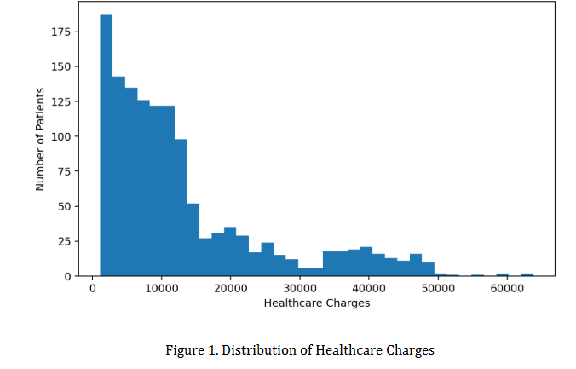
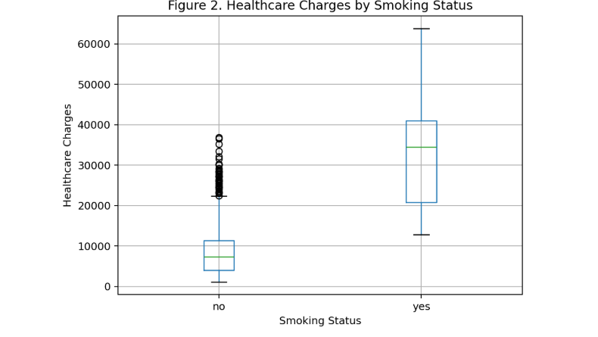

2.3 Stakeholders

- Patients or users: may benefit from understandable estimates for educational or planning purposes.
- Healthcare and insurance analysts: can use the system as a basic analytical demonstration for examining cost patterns.
- Data scientists and developers: can use the project as an example of an end-to-end predictive application.
- Academic supervisors and evaluators: can assess the integration of data analysis, machine learning, software engineering, and evaluation.
- Future system administrators: may extend the application with stronger models, authentication, databases, and monitoring.

2.4 Supporting Data/Research

WHO guidance emphasizes that financial protection is an important health-system objective and that out-of-pocket payments can create financial hardship. Although the supplied insurance dataset is not a population-level health-financing database, this broader context supports the importance of understanding healthcare expenditure. From a technical perspective, scikit-learn describes ordinary least-squares LinearRegression as fitting coefficients that minimize the residual sum of squares between observed and predicted targets. This provides the mathematical basis for the predictive component of the project.

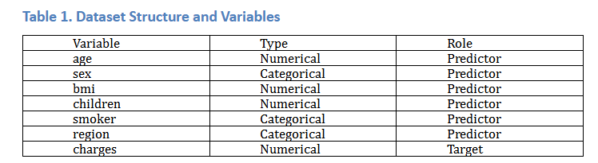

Chapter 3: Solution Design and Implementation
3.1 Development and Design Process
Development was organized into incremental stages. First, the dataset was inspected for dimensions, data types, missing values, and duplicates. Second, descriptive statistics and visualizations were developed to understand the distribution of costs and relationships between predictors and charges. Third, a reproducible machine-learning pipeline was created so preprocessing and prediction use the same feature transformations. Fourth, the model was evaluated on unseen test data. Finally, the components were integrated into a Streamlit interface with separate pages for analysis, prediction, and evaluation.
A modular software structure was used. The data_preprocessing module loads and cleans data; the model_training module constructs, trains, evaluates, and saves the model; the prediction module formats user input and generates estimates; and app.py provides the user interface. This separation improves maintainability and reduces the risk of mixing presentation logic with model logic.

3.2 Tools and Technologies Used

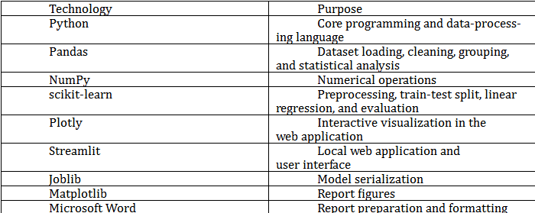

3.3 Solution Overview
The final system consists of three modules. Module 1 is the analytics layer. It displays dataset statistics, data preview, age groups, BMI categories, smoking-related cost differences, age-cost relationships, BMI-cost relationships, and regional comparisons. Module 2 is the prediction layer. The user enters age, sex, BMI, number of children, smoking status, and region, and the application returns the predicted healthcare charge. Module 3 is the evaluation layer. It displays R², MAE, MSE, RMSE, actual-versus-predicted values, residuals, and regression coefficients.
The predictive model is represented as a linear combination of transformed features. In general form, ŷ = β₀ + β₁x₁ + β₂x₂ + … + βₚxₚ. Categorical features are represented using one-hot encoding with a reference category. The implementation uses an 80:20 train-test split with random state 42. The trained model is stored as a Joblib file so the application can reuse the model without retraining every time.
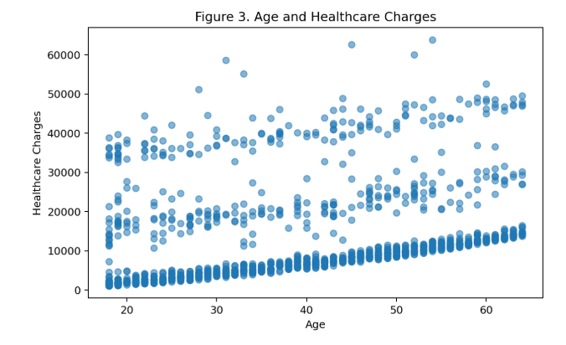

3.4 Engineering Standards Applied

ISO/IEC 25010:2023 provides a software product quality model that can be used to specify and evaluate software quality characteristics. For this project, the principles are applied through functional suitability, usability, reliability, maintainability, and performance considerations. The application separates data, model, prediction, and interface responsibilities, uses explicit validation through widgets, and provides understandable outputs.
The NIST Artificial Intelligence Risk Management Framework is also relevant because it identifies trustworthy-AI characteristics including validity and reliability, safety, security and resilience, accountability and transparency, explainability and interpretability, privacy enhancement, and fairness. In this project, the most directly applicable principles are validity, reliability, transparency, and explainability. Model performance is measured on held-out data, coefficients are displayed, and the application clearly presents itself as an analytical prediction system rather than a clinical decision-maker.

3.5 Solution Justification

Multiple linear regression was selected as a strong baseline because the dataset is small, the target is continuous, the input variables are readily encoded, and the model is highly interpretable. A more complex model could potentially improve predictive performance, but increased complexity would make the explanation of individual effects more difficult. The chosen approach therefore balances predictive usefulness with transparency, which is appropriate for an academic capstone focused on both analytics and software implementation.

Chapter 4: Results and Recommendations
4.1 Evaluation of Results
After removing one duplicate record, 1,337 observations were available. There were no missing values in the seven variables. The data was divided into 1,069 training records and 268 testing records. The fitted multiple linear regression model achieved an R² of 0.8069, meaning that approximately 80.69% of the variation in the test-set target was explained by the fitted linear model under this split.
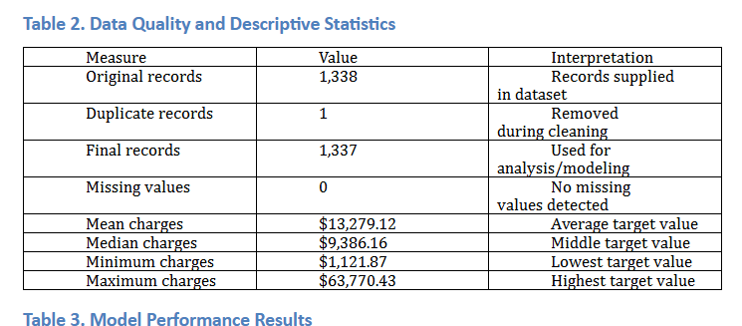
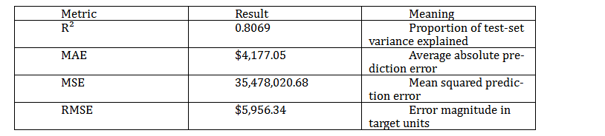
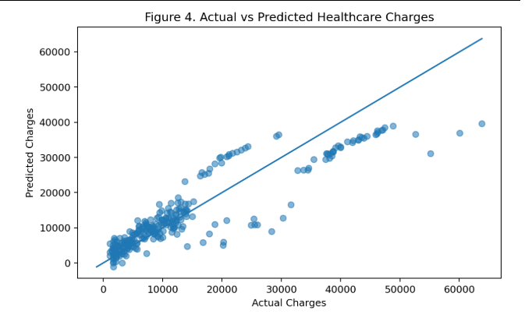
The model results indicate useful baseline predictive capability. The MAE of approximately $4,177 means that, on average, the absolute difference between predicted and actual charges on the test set is around $4,177. The RMSE of approximately $5,956 gives greater weight to larger errors and therefore indicates that some observations have substantially larger deviations. The results should be interpreted as performance on this dataset and split, not as a guarantee of performance on another population.

  - Challenges Encountered

- Data-quality handling: one duplicate record had to be removed before modeling.
- Categorical variables: sex, smoker, and region cannot be used directly by a standard linear regression model, so one-hot encoding was required.
- Model evaluation: a high or low individual prediction is not sufficient evidence of model quality; held-out metrics and residual analysis were therefore included.
- Local deployment: Streamlit depends on the correct Python environment and package installation. The final project uses python -m streamlit run app.py as a robust launch method.
- Interpretation: healthcare charges are influenced by factors not present in the dataset. Therefore, model outputs are estimates and should not be interpreted as medical or financial certainty.

4.3 Possible Improvements

Future versions could compare linear regression with Random Forest Regression, Gradient Boosting, XGBoost, or other nonlinear models. Cross-validation could provide a more robust estimate of generalization performance. Hyperparameter optimization could be introduced for nonlinear models. Feature engineering could include interaction terms, especially age-smoking and BMI-smoking interactions, because healthcare costs may not change linearly across all combinations of variables. Additional validated variables such as income, healthcare utilization, medical history, plan type, and geographic cost indicators could improve the model if legally and ethically available.
4.4 Recommendations
- Use the current application as an educational and analytical prototype rather than an automated clinical or insurance decision system.
- Add cross-validation and model comparison before considering broader deployment.
- Add privacy controls and avoid storing personally identifiable health information in the prototype.
- Introduce model monitoring and periodic retraining if the system is ever connected to changing real-world data.
- Perform fairness and subgroup evaluation before using predictions for decisions affecting individuals.
- Deploy only after domain experts validate data definitions, target meaning, security, and appropriate use.

Chapter 5: Reflection on Learning and Personal Development
5.1. Key Learning Outcomes:
5.1.1 Academic Knowledge
This project strengthened my understanding of the complete data-science lifecycle. I applied concepts from statistics, exploratory data analysis, supervised learning, categorical encoding, regression, and model evaluation to a real dataset. Previously, individual techniques could be understood as separate classroom topics; the capstone demonstrated how they depend on one another. Data cleaning affects analysis, feature representation affects model training, and evaluation determines whether a model is useful. The project also deepened my understanding of the distinction between association and causation. For example, a large coefficient for smoking status in a fitted model indicates a strong statistical association in the dataset, not proof that the model has established a causal medical effect.
    - Technical Skills
I developed practical skills in Python, Pandas, scikit-learn, Plotly, Streamlit, Joblib, and modular application development. I learned how to construct preprocessing and regression steps in a pipeline, how to divide data into training and testing sets, and how to calculate R², MAE, MSE, and RMSE. I also learned how to convert a machine-learning model into an interactive web application and how to organize code into modules rather than placing all logic in one script.
    - Problem-Solving and Critical Thinking
The project improved my ability to debug systematically. Instead of assuming that an error was caused by the model, I learned to separate data problems, preprocessing problems, package/environment problems, and application problems. Evaluating residuals and multiple metrics also encouraged a more critical approach to model performance. A single accuracy-like number cannot describe a regression model completely.
5.2. Challenges Encountered and Overcome:
5.2.1 Personal and Professional Growth
One of the most useful parts of the project was dealing with implementation friction. Installing dependencies, running Streamlit locally, structuring files, and ensuring that the model and interface used identical preprocessing required patience and attention to detail. These difficulties improved persistence and encouraged a step-by-step debugging approach. The experience also showed that successful software engineering involves more than writing model code; environment configuration, usability, documentation, and testing are equally important.

5.2.2 Collaboration and Communication

Where feedback from supervisors, peers, or evaluators is available, the project demonstrates the importance of communicating technical decisions in simple terms. Explaining why a model was selected, what its metrics mean, and why predictions have limitations is essential when working with non-specialist stakeholders. This experience strengthened the ability to convert technical findings into clear project documentation and presentations.
5.3. Application of Engineering Standards:
Applying ISO/IEC 25010 quality concepts encouraged attention to usability, reliability, maintainability, and functional suitability rather than focusing only on predictive performance. NIST AI RMF principles encouraged consideration of validity, transparency, interpretability, privacy, and fairness. These principles shaped the decision to include model metrics and coefficients in the application and to state explicit limits on how the predictions should be used.
5.4 . Insights into the Industry
The project provided a realistic view of how data-science solutions are developed in industry. A machine-learning model is only one component of a usable system. Real-world projects also require data governance, reproducibility, testing, deployment, monitoring, documentation, security, and communication with stakeholders. The project therefore increased my awareness that AI and data-science careers require both technical depth and software-engineering discipline.
5.5 Conclusion of Personal Development:
Overall, the capstone strengthened my confidence in building an end-to-end AI and data-science application. I gained experience moving from a raw dataset to a cleaned analytical dataset, then to a predictive model, and finally to a deployable local web interface. The combination of statistical reasoning, programming, machine learning, visualization, and documentation has prepared me for larger projects involving production-oriented data applications.

Chapter 6: Conclusion
This capstone project developed a Healthcare Cost Prediction and Analytics System that addresses the challenge of estimating healthcare charges from demographic, lifestyle, and regional variables. The solution combines data cleaning, exploratory analysis, multiple linear regression, model evaluation, and Streamlit-based local deployment. The dataset contained 1,338 observations; after removing one duplicate, 1,337 records were used. The model achieved an R² of approximately 0.807 with an MAE of approximately $4,177 and RMSE of approximately $5,956 on the held-out test set.
The main value of the project is not only the numerical prediction but also the integration of the prediction into an understandable application. Users can inspect the data, enter a hypothetical patient profile, receive a cost estimate, and review model performance. This creates a complete demonstration of the path from data to decision-support interface.
At the same time, the project recognizes that healthcare is a high-impact domain. The model should therefore be treated as a baseline analytical tool, not as a replacement for professional judgement or as an autonomous system for medical or insurance decisions. Future work should focus on stronger validation, richer data, fairness analysis, privacy protection, model comparison, and domain-expert review before any real-world deployment.
References
  - Kaushik, K., Bhardwaj, A., Dwivedi, A. D., & Singh, R. (2022). Machine learning-based regression framework to predict health insurance premiums. International Journal of Environmental Research and Public Health, 19(13), 7898. https://doi.org/10.3390/ijerph19137898
  - Ul Hassan, M., et al. (2021). A computational intelligence approach for predicting medical insurance cost. Mathematical Problems in Engineering, 2021, 1162553. https://doi.org/10.1155/2021/1162553
  - Cenita, J. A. S., Asuncion, P. R. F., & Victoriano, J. M. (2023). Performance evaluation of regression models in predicting the cost of medical insurance. arXiv.
  - Sabarinath, U. S., & Mathew, A. (2024). Medical insurance cost prediction. Indian Journal of Data Communication and Networking. https://doi.org/10.54105/ijdcn.D5037.04040624
  - Sabarinath, U. S., & Mathew, A. (2024). Medical insurance cost prediction [Data set]. Zenodo.
  - Kaushik, K., Bhardwaj, A., Dwivedi, A. D., & Singh, R. (2022). Machine learning-based regression framework to predict health insurance premiums. PubMed. https://pubmed.ncbi.nlm.nih.gov/35805557/
  - Machine learning for an explainable cost prediction of medical insurance. (2024). Machine Learning with Applications, 15, 100516. https://doi.org/10.1016/j.mlwa.2023.100516
  - Estimation and prediction of hospitalization and medical care costs using regression in machine learning. (2022). BioMed Research International.
  - Bertsimas, D., et al. (2018). Supervised learning methods for predicting healthcare costs: Systematic literature review and empirical evaluation. Health Services Research.
  - Predictive interpretable analytics models for forecasting healthcare costs using open healthcare data. (2024). International Journal of Medical Informatics.
Appendices
Appendix A: System User Manual

Install Python and the packages listed in requirements.txt.
Open PowerShell in the healthcare_cost_prediction project folder.
Run: python -m pip install -r requirements.txt
Run: python -m streamlit run app.py
Open the local URL displayed by Streamlit, normally http://localhost:8501.
Use Module 1 to inspect the dataset and cost patterns.
Use Module 2 to enter a hypothetical profile and generate a prediction.
Use Module 3 to review model performance and coefficients.

Appendix B: Core Prediction Variables

Input variables: age, sex, BMI, children, smoker, and region. Target variable: charges.

Appendix C: Mathematical Model

The model follows the ordinary least-squares linear regression form: ŷ = β₀ + β₁x₁ + β₂x₂ + … + βₚxₚ. For categorical variables, one-hot encoded variables are used. The fitted coefficients include approximately +248.21 for age, +318.70 for BMI, +533.01 for children, −101.54 for sex_male, +23,077.76 for smoker_yes, −391.76 for region_northwest, −838.92 for region_southeast, and −659.14 for region_southwest, relative to the selected reference categories.

Appendix D: Project Limitations

The dataset is relatively small and contains limited predictors. It represents insurance charges rather than a complete medical record, and the meaning and collection context of the target variable are fixed by the source dataset. The model therefore should not be generalized to other populations without validation. The application also does not process identifiable patient records or connect to a live healthcare information system.

Report Formatting Rules
1. General Formatting
● Font: Times New Roman or Arial
● Font Size:
○ Headings: 14 pt, bold
○ Subheadings: 12 pt, bold
○ Body Text: 12 pt
● Line Spacing: 1.5
● Alignment: Left-aligned for body text; headings can be centered
● Margins: 1-inch (2.54 cm) on all sides
2. Title Page
● Font Size: 16 pt, bold for title
● Spacing: Double-spaced, center-aligned
3. Headings and Subheadings
● Main Headings: Bold, 14 pt
● Subheadings: Bold, 12 pt
● Numbering: Use consistent numbering for headings (e.g., 1. Introduction, 2. Problem Statement).
4. Paragraph Formatting
● Indentation: First line of each paragraph indented by 0.5 inches.
● Spacing Between Paragraphs: Leave a blank line.
5. Tables and Figures
● Caption: Title above tables and below figures.
● Font Size: 10 pt for content in tables/figures.
● Alignment: Center tables/figures.
● Numbering: Sequential numbering for tables and figures.
6. References and Citations
● Citation Style: Follow APA or specified style for citations.
● Font Size: 12 pt
● Spacing: Single-spaced for individual references, double-spaced between references.
7. Page Numbers
● Location: Bottom right corner of each page (except title page).
● Font Size: 12 pt.
8. Word Count
● The report should have 3000 words.

Capstone Project Evaluation Rubric
Total Marks: 100%

Criteria | Weight | Excellent (4) | Good (3) | Satisfactory (2) | Needs  Improvement  (1)
Understanding of Problem | 25% | Comprehensive understanding of the problem. | Good  understanding with minor  gaps. | Basic  understanding, some important details missing. | Lacks  understanding of the problem.
Analysis &  Application | 30% | Insightful and  deep analysis  with relevant  theories. | Good  analysis, but  may lack  depth. | Limited  analysis;  superficial  application. | Minimal  analysis; no  theory  application.
Solutions &  Recommendations | 20% | Practical,  well-justified,  and innovative. | Practical but  lacks full  justification. | Basic solutions with weak  justification. | Inappropriate or unjustified  solutions.
Organization &  Clarity | 15% | Well-organized, clear, and  coherent. | Generally  clear, but  some  organization  issues. | Inconsistent  organization,  unclear in parts. | Disorganized;  unclear or  confusing  writing.
Use of Evidence | 5% | Effectively uses case-specific  and external  evidence. | Adequate use of evidence,  but limited  external  sources. | Limited  evidence use;  mostly case  details. | Lacks evidence to support  statements.
Use of Engineering Standards | 5% | Thorough and  accurate use of standards. | Adequate use with minor  gaps. | Limited or  ineffective use of standards. | No use or  incorrect  application of  standards.

